Preparation Instructions of Model Presentation Day

Please note the following details about the format and set up of the exhibition for your preparation. Each team will need to set up a corner with a table and one or more display board(s) for presenting and demonstrating your product(s) and ideas.

- Exhibition Display Board:

- One or two display board(s) with size A1 or A2 will be provided for each team. Please see below the sample of the display stand and board.
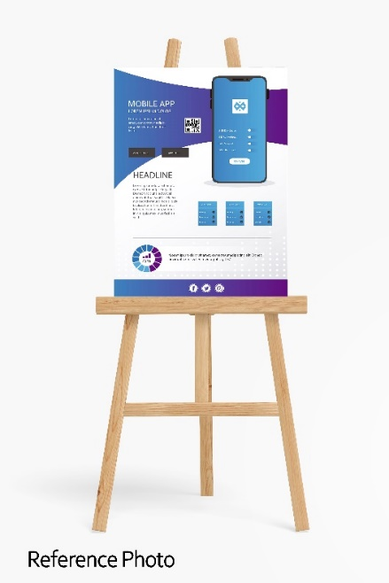
- The following information can be printed on the board:
  - Product name
  - Objective
  - Target SEN type(s) and aspects of university life
  - Photos
  - Introduction of product: functions, how to use, how it benefits students with SEN and contribute to a barrier-free campus, any special/ significant features, etc.
  - Note: Execution plan and actual expenses are not required, but you might prepare these for your presentation and Q & A session

- Texts in both Chinese and English are required with minimum font size of 16 point.
- Each team can request for no more than 2 display stands with the display board of size A1 and/or A2. Please let us know the no. of display stand and size of display board on or before 20 April.
- You need to bring along all the electronic materials (i.e. iPad / computer/ charger) that you need (e.g., for showing your short video).
- Submission Requirement:

- Deadline of the model submission: 23:59, 20 April 2022
- Please send the following items to sdss@cuhk.edu.hk:
- One or two A2 or A1 poster(s) in PDF format (for printing on the Exhibition Display Board*);
- A short video clip of no more than 2 minutes to demonstrate its use and functions. (The video will be provided to the judging panel as reference of scoring. It will also be exhibited and shared on the social media platform(s) during/after the presentation day);
- The final proposal.
- Email title: Barrier-free Campus Design Competition -Final Round Model (please state the project number)

* Please set CMYK and create 3mm bleed on all edges for your poster design. For more details, you might visit: https://www.e-print.com.hk/blog/%E8%A8%AD%E8%A8%88%E7%A8%BF%E4%BB%B6%E6%99%82%E7%82%BA%E4%BD%95%E3%80%8C%E5%87%BA%E8%A1%80%E4%BD%8D%E3%80%8D%E6%9C%83%E9%82%A3%E9%BA%BC%E9%87%8D%E8%A6%81%E6%80%A7/

